Technical report

System design

Ignat mamedov Ilarion petriv

2024

Table of Contents

1. Analysis 3

1.1. Class Diagram 3

1.1.1. Class Diagram 3

1.1.2. Menu Options 4

1.2. Code Smells 4

1.3. Structural Problems in the Code 7

1.3.1. Printers Inheritance 7

1.3.2. ‘HousedPrinter’ Redundance 7

1.3.3. Package Structure 8

2. Design 9

2.1. Code Improvements and SOLID Principles 9

2.1.1. Applying Single Responsibility Principle 9

2.1.2. Applying Open-Closed Principle 10

2.1.3. Applying Interface Segregation 11

2.2. Design Patterns 12

2.2.1. Adapter Pattern 12

2.2.2. Factory Pattern 13

2.2.3. Singleton Pattern 14

2.2.4. Facade Pattern 15

2.2.5. Strategy Selection Using Strategy Pattern 16

2.3. Global Overview 17

3. Implementation 19

3.1. Implement Your Design 19

3.2. Extension of the System 19

3.2.1. Observer 19

3.2.2. Integration of a Multicolor Printer 21

3.2.3. Adding Support for CSV Source 21

3.2.4. Implementing the Second Printing Strategy 22

3.3. Testing 22

3.3.1. Factual Error in the Truth Table 23

3.3.2. Oversight in the Truth Table 23

4. Conclusion 26

5. Software Architecture 28

Introduction 28

Use case diagram 29

System Sketch 30

Component + Deployment diagram 31

Activity Diagram 33

Sequence diagrams 34

Architectural Patterns 37

# 1. Analysis

## 1.1. Class Diagram

### 1.1.1. Class Diagram

**Figure 1**

*Initial Class Diagram*

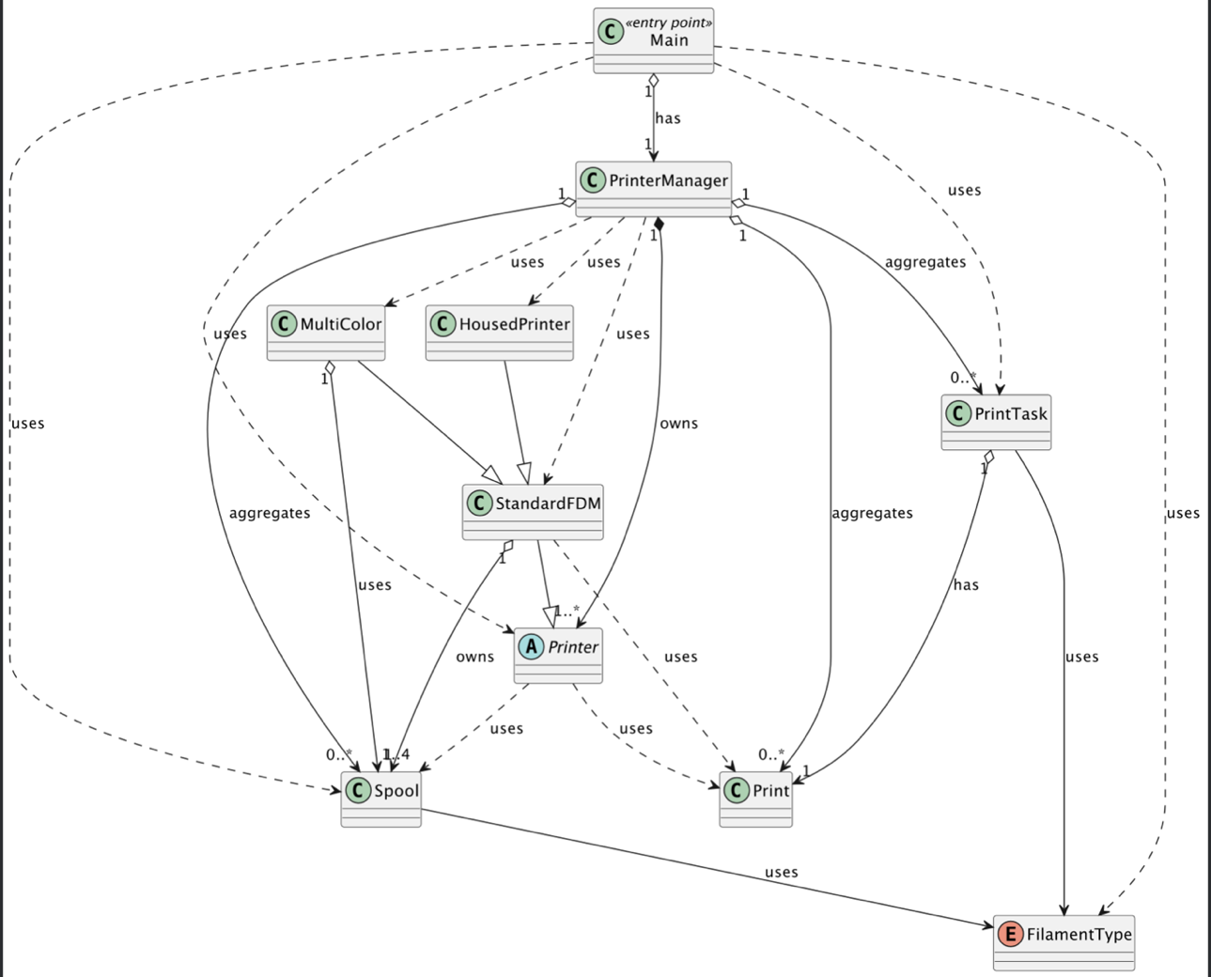

The biggest problem of the system is classes being too dependent on each other’s implementation details. A change in one class would often require changes in another, making the system not scalable and difficult to maintain.

As illustrated in the diagram, examples of this issue are the ‘Main’ and ‘PrinterManager’ classes. The ‘Main’ class is tightly coupled to ‘PrinterManager’, ‘Spool’, ‘Printer’, ‘PrintTask’, and ‘FilamentType’. If any of these classes (e.g., ‘PrinterManager’) changes its behavior or dependencies, the Main class might also require modifications.

This tight coupling means adding a new type of printer would require changes to ‘PrinterManager’. Moreover, ‘PrinterManager’ aggregates too many responsibilities, such as managing printers, spools, and print tasks, which makes it a ‘God’ class.

To sum up, covered issues make system hard to scale and test. For instance, testing ‘Main’ or ‘PrinterManager’ independently is challenging since they rely on multiple concrete implementations.

### 1.1.2. Menu Options

The table below illustrates each option of the application menu.

**Table 1**

*Menu options*

|  |  |  |
| --- | --- | --- |
| Menu Option | Explanation | Dependent Classes |
| (1) Add new Print Task | Allows the user to add a new print task by selecting a print, filament type, and colors | Print, FilamentType, Spool, PrinterManager |
| (2) Register printer completion | Prompts user to select specific printer id that has completed print task | Printer, PrintTask, PrinterManager |
| (3) Register printer failure | Prompts user to select specific printer id that has failed print task | Printer, PrintTask, PrinterManager |
| (4) Change printing style | Prompts user to select new print strategy, but actually does not do anything. Was left purposefully to add this feature in future | None |
| (5) Start print queue | Starts the initial print queue managed by the PrinterManager | PrinterManager |
| (6) Show prints | Displays all available prints | Print, PrinterManager | Print, PrinterManager |
| (7) Show printers | Displays all available printers and their current tasks | Printer, PrintTask, PrinterManager |
| (8) Show spools | Displays all available spools | Spool, PrinterManager |
| (9) Show pending tasks | Gets all print tasks from printer manager and displays them | PrintTask, PrinterManager |
| (0) Exit | Stops the infinite loop for reading user input and closes application | None |

## 1.2. Code Smells

**Long method.**

* Where: In Main class, the run() method.
* What’s wrong: The method has a very long sequence of if-else statements to handle user menu option choice.
* Why is it wrong: It is hard to read through the code and makes it harder to maintain options.
* Possible solution: Use a switch case instead.
* Name of code smell: Long method.

**Long method.**

* Where: In Main class, the addNewPrintTask() method.
* What’s wrong: This method consists of a very long sequence of conditions and nested loops.
* Why is it wrong: Similar to the previous example, it is hard to read through the method and understand the logics.
* Possible solution: Separate the concerns, by splitting parts of the method into separate smaller functions.
* Name of code smell: Long method.

**Duplicate Code.**

* Where: In Main class, methods readPrintsFromFile(), readPrintersFromFile(), and readSpoolsFromFile().
* What’s wrong: Each method contains similar code for reading JSON files and parsing their contents.
* Why is it wrong: Duplicate code is harder to maintain, as well as harder to read through the Main class.
* Possible solution: Extract method into separate method outside the Main class. I see the possibility of using a generics and functional interfaces for different object parsing. A great example of this is implementation of LambdaReader from SDP module, where we have used Function interface to turn the list of columns into desired Class type.
* Name of code smell: Duplicate Code.

**Large Class.**

* Where: The Main class itself.
* What’s wrong: A class have to many responsibilities, including file reading, user input handling, handling menu options etc.
* Why is it wrong: Hard to read, understand and maintain.
* Possible solution: Separate functionality between different classes, trying to adhere to Single Responsibility Principle.
* Name of code smell: Large Class.

**Long Parameter list**

* Where: PrinterManager class, the addPrint() method.
* What’s wrong: The method accepts 7 different parameters.
* Why is it wrong: Similar to previous “code smells”, this large amount of parameters makes it harder to read and, of course, maintain.
* Possible solution: Accept one parameter of Print class.
* Name of code smell: Long Parameter List.

**Dead code**

* Where: PrinterManager class, the getSpoolByID() method.
* What’s wrong: The method is not used in the program.
* Why is it wrong: It is unnecessary to keep unused methods.
* Possible solution: Remove method.
* Name of code smell: Dead code.

**Duplicate code**

* Where: PrinterManager class, the registerCompletion() and registerPrintFailure() methods.
* What’s wrong: Both methods contain similar code for finding a printer by ID and handling the print task.
* Why is it wrong: Duplicate code increases maintenance effort and the risk of inconsistencies.
* Possible solution: Extract duplicate code into a separate method.
* Name of code smell: Duplicate Code.

## 1.3. Structural Problems in the Code

### 1.3.1. Printers Inheritance

The current printer inheritance structure consists of an abstract class, Printer, which serves as the base for all printer types. StandardFDM inherits from Printer and represents a standard FDM printer. The hierarchy is then divided into specific types: HousedPrinter, which extends StandardFDM to represent housed printers, and MultiColor, which also extends StandardFDM to, as the name implies, handle multicolor printing.

One significant problem is the depth of the inheritance hierarchy. Changes to Printer or StandardFDM could potentially break functionality in HousedPrinter or MultiColor.

This close relationship in the hierarchy not only increases the complexity of the maintenance, but also increases the chances of unexpected side effects.

**Figure 2**

*Printer Inheritance*

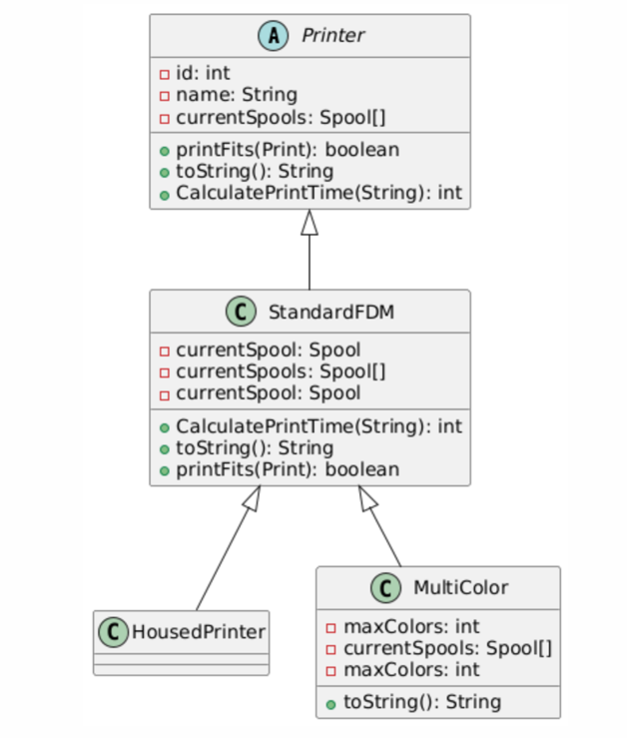

### 1.3.2. ‘HousedPrinter’ Redundance

In my opinion, having a HousedPrinter class is redundant. As you can see on the diagram above, it doesn’t actually extend the StandardFDM by any means (e.g. no specific class field or methods), making this inheritance relationship irrational.

It is clear for me that developer initially created this class to have a distinct printer type and might have had some additional functionality planned for it. However, as it does not contain any meaningful functionality, this could have been avoided by having a class field, such as “isHoused” in StandardFDM.

### 1.3.3. Package Structure

Currently the system has one root package, containing Main and PrinterManager classes which and a sub-package “Models”, which contain all the application used classes. This sub-package, however, does not follow any rules in grouping classes. All of the classes coexist in the same place.

The inconsistency in package structure can cause confusion about where to find or place new classes. It can also make it harder to understand the organization of the codebase.

**Figure 3**

*Package Structure*

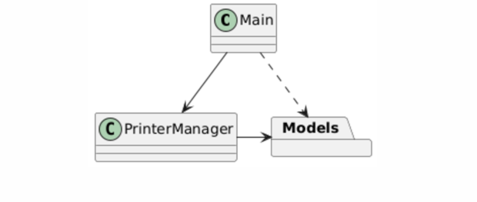

# 2. Design

## 2.1. Code Improvements and SOLID Principles

### 2.1.1. Applying Single Responsibility Principle

Right now, all the core application methods are mainly distributed between Main and PrinterManager class, making them God classes. As you can see on the diagram (Figure 4), they do “everything”, there is no separation of concerns.

**Figure 4**

*Main and PrinterManager Classes Having Too Many Concerns*

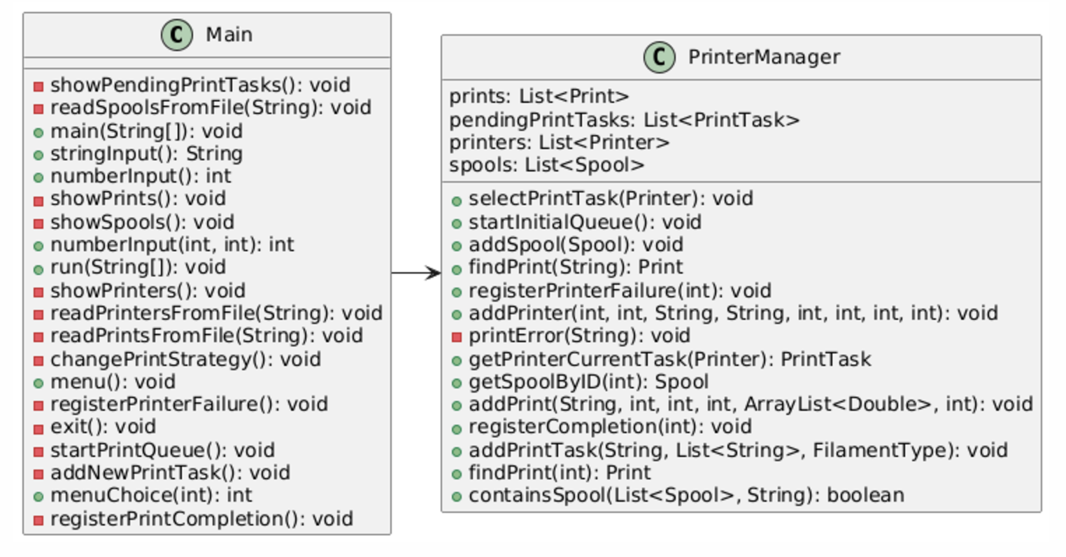

As Single Responsibility rule states, a class can have only one responsibility. This not only improves the organization of the system and avoids class coupling but also allows us to test Application better. We can obviously apply this principle to both Main and PrinterManager.

When it comes to Main, it should only start the application, by initializing all the components of the system and not manage menu, input and file reading. We will introduce:

* UserInputHanlder, which will handle console operations for string and number input.
* MenuManager, which will display the menu and handle user’s choice.
* FileReader, which will manage file operations.

As far as PrinterManager is concerned, we can separate concerns into small, specialized classes:

* PrinterHandler – handles printers.
* PrintTaskHanlder – handles print tasks.
* SpoolManager – manages spools.

In our opinion, this change will allow to handle concerns better. On a following diagram (Figure 5), we show what are the system components after applying the principle. There are, obviously, more changes coming, as we continue to apply SOLID principles. Thus, not all methods from the previous diagram are shown and no association is drawn. This diagram exists purely to depict that God classes of the system are separated into smaller classes, each responsible for one functionality.

**Figure 5**

*Classes After Applying SRP Principle*

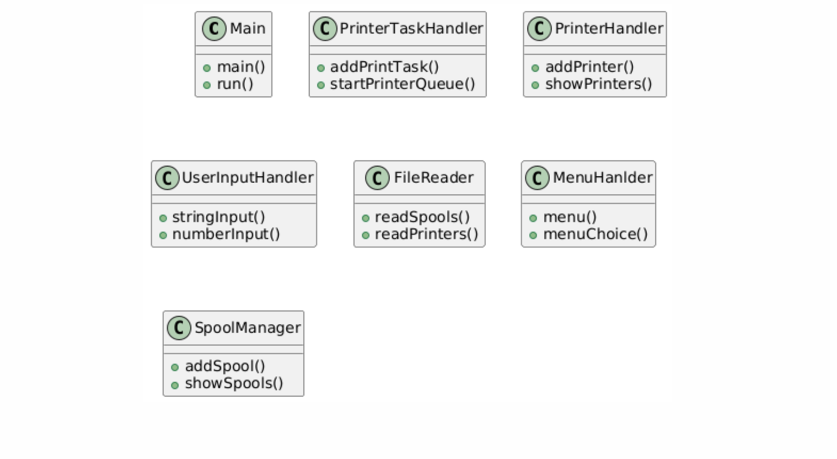

### 2.1.2. Applying Open-Closed Principle

Right now, Application depends only on console input and JSON File reading. When it comes to user input, we understand that current setup provides fast usage to the owner, however, what if in future, as his company grows, there would be a need in GUI? Or, from testing perspective, it is not really possible to implement Unit-testing for input right now.

Similarly, now program relies on JSON, however, what if there should be CSV file support? Or perhaps, owner will save the important data in the database?

Current setup is not open for extension, as adding new type of input or data source, will require code modification. This can be fixed creating specific interface per problem. Having an interface for both user input and data reading will allow to have multiple sources of truth. Whether it is a mock input, GUI input or console input, the application logic won’t need to be modified.

This will allow to extend and test application more easily.

On the diagram (Figure 6), we have displayed possible classes, that can easily the extend system with this setup. JSONFileReader class, depicted on the diagram, would handle the current logic for reading the data out of Json files.

**Figure 6**

*Applying Open-Closed for Input and Data Reading*

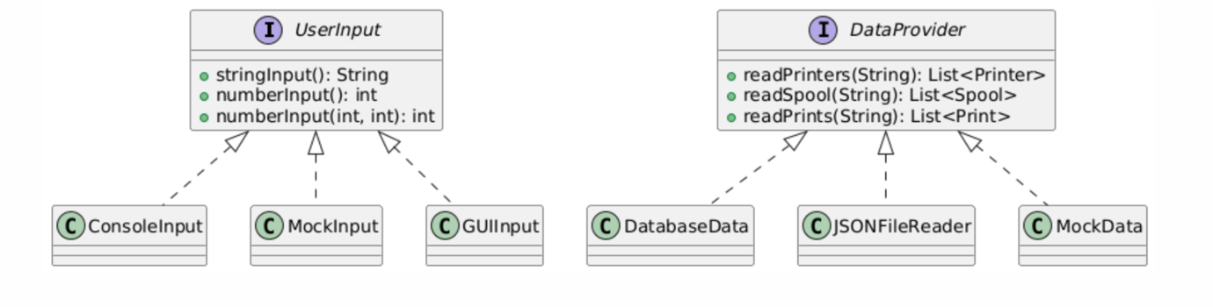

### 2.1.3. Applying Interface Segregation

The previous example of user input and data reading can be further improved, if we would.

apply Interface Segregation principle for better flexibility. This is relevant for IDataProvider interface from the Figure 6 diagram. This is not really flexible and can be improved.

As we would implement large interface, we would have to implement all of the existing interface methods, which is not always the case.

On a Figure 7, we show, what is the advantage of splitting the interface. With this setup, we can have different implementation of Data providers. One class can implement multiple data provider interfaces, allowing for flexible usage and different combinations.

**Figure 7**

*Example Usage*

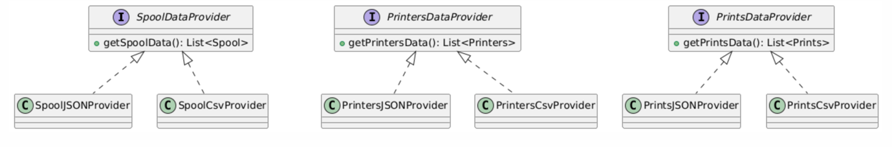

On the following figure, we display how we might handle getting data in the Application now (this might change after applying Design Patterns).

**Figure 8**

*A Possible Solution Relevant to Current Setup*

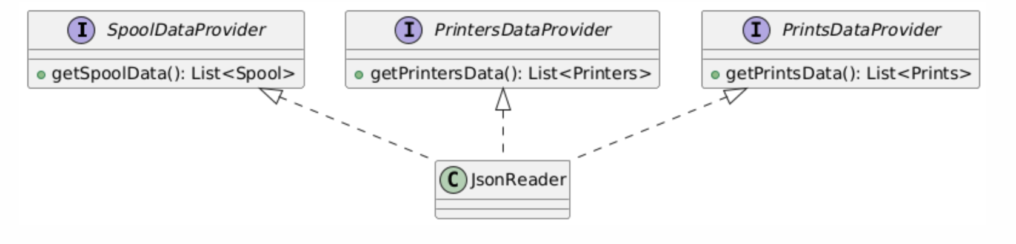

## 2.2. Design Patterns

### 2.2.1. Adapter Pattern

**Issue:** The original code tightly coupled the JSON parsing logic with the application logic, violating the Single Responsibility Principle and making it difficult to:

* Extend support to new data formats (e.g., XML, CSV).
* Maintain or modify the parsing logic without affecting the core logic.
* Test the application independently of the data format.

**Fix:** Applied the Adapter Pattern to decouple data sources from the application logic and standardize data handling:

* All data sources (JSON, XML, CSV, etc.) are now converted into a common HashMap format. This is done via “SourceAdapter” implementations (e.g., “JsonAdapter”).
* Each model (Print, Spool, Printer) now includes a “fromMap” method, which encapsulates the logic for creating an instance of the model from a HashMap. This simplifies object creation and centralizes it within the models.
* The core application logic interacts only with the “ISourceAdapter” interface, which ensures data is provided in a consistent HashMap format, regardless of the original source.

Figure 9 illustrates how adapters transform various data sources into a unified format that the application can easily consume.

**Figure 9**

*Adapter Pattern*

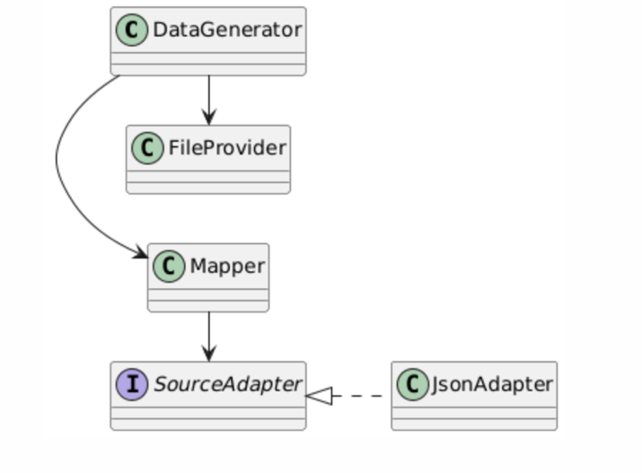

**Justification:** This approach excels due to its modularity. By isolating responsibilities, the system achieves high flexibility and maintainability. Adapters focus solely on transforming data formats, while models handle object creation via a standardized process. The core logic remains entirely abstracted from the specifics of data parsing or source format.

### 2.2.2. Factory Pattern

**Issue:** The original code tightly couples the logic for reading and creating “Printer” objects with the “PrinterManager” class. This causes several issues:

* The “addPrinter” method in “PrinterManager” is overloaded with the responsibility of creating different types of Printer objects.
* Adding a new printer type (e.g., “ResinPrinter”) requires modifying the “addPrinter” method, which violates the Open/Closed Principle (OCP).
* The creation logic for printers is embedded into “PrinterManager”, making it hard to reuse in other parts of the application.

**Fix:** Applied the Factory Pattern to decouple printer creation logic from the “PrinterManager” and integrate it with “Mapper”:

* Introduced a “PrinterFactory” class to encapsulate the logic for creating “Printer” objects.
* The “PrinterFactory” class determines the correct type of “Printer” to create based on the “type” field, ensuring consistent and reusable logic.
* Removed direct printer creation logic from “PrinterManager” and delegated it to the “PrinterFactory”. The “Mapper” now directly utilizes the factory to create “Printer” objects from data.

**Justification:** The Factory Pattern centralizes printer creation logic in “PrinterFactory”, making the system modular, maintainable, and extensible. Adding new printer types requires changes only in the factory, adhering to the Open/Closed Principle, while “Mapper” and “PrinterManager” remain focused on their respective responsibilities. This separation ensures consistency, reduces duplication, and simplifies future modifications, making the code cleaner and easier to manage, as illustrated in Figure 10.

**Figure 10**

*Factory-Based Creation of Print Objects*

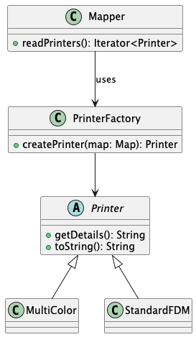

### 2.2.3. Singleton Pattern

**Issue:** The current implementation of “PrinterManager” is responsible for storing and managing all data related to printers, spools, and tasks. Multiple instances of “PrinterManager” can be created, leading to inconsistent resource management and potential duplication of effort when interacting with printers and tasks. This undermines the concept of a centralized system for managing these resources.

**Fix:**

* Made the “PrinterManager” constructor private to prevent external instantiation.
* Introduced a static getInstance method to ensure only one instance of “PrinterManager” is created and shared across the application.
* Ensured that all operations, such as adding printers, managing spools, and assigning tasks, are performed on a single centralized instance.
* Replaced direct instantiations of “PrinterManager” in “Facade” with “PrinterManager.getInstance()” to guarantee consistent access to the shared instance.

**Justification:** The Singleton Pattern directly addresses the problem by ensuring that only one instance of PrinterManager exists, centralizing resource management and preventing redundant operations. This approach avoids conflicting states across multiple instances and guarantees consistent behavior. By ensuring all parts of the application interact with the same instance, the design reduces complexity and improves maintainability. This diagram (Figure 11) illustrates the Singleton Pattern applied to PrinterManager, ensuring a single, shared instance accessed globally through Facade and preventing multiple conflicting instances.

**Figure 11**

*Singleton Pattern Implementation for Centralized* PrinterManager *Instance*

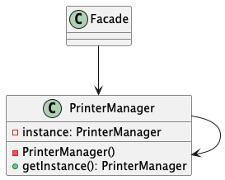

### 2.2.4. Facade Pattern

**Issue:** The original implementation of “Main” directly handles logic for user input, file management, and interactions with “PrinterManager”. This creates several issues:

* “Main” integrates user input handling, file operations, and printer management, violating the Single Responsibility Principle.
* “Main” is overly large, mixing different concerns, making it difficult to maintain or extend.
* Tasks like menu display and command processing are implemented redundantly, complicating code reuse.

**Fix:**

* Created “Facade” class to encapsulate all interactions with “PrinterManager” and related components (e.g., file reading, print queue management).
* Moved all high-level operations, such as “addPrintTask” or “startPrintQueue”, into the Facade.
* Added “UserInput” class to handle all user input operations (e.g., reading integers, strings, and menu choices).
* *Simplified the input-related logic in* “Main” *by delegating it to* “UserInput”*.*

**Justification:** As illustrated in Figure 12, the application now uses the Facade Pattern to provide a unified interface for managing PrinterManager and related components. This reduces coupling, improves code clarity, and aligns with the Single Responsibility Principle. The addition of “UserInput” ensures cleaner, reusable input handling. This design simplifies the application, making it easier to extend and maintain by isolating user interaction, core logic, and resource management.

**Figure 12**

*Facade Integration for Simplified Management of PrinterManager and Related Components*

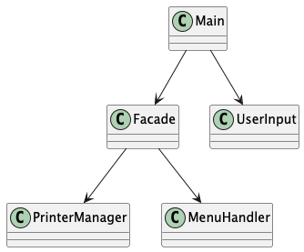

### 2.2.5. Strategy Selection Using Strategy Pattern

**Issue:** The current method “changePrintStrategy” acts as a placeholder, and author left a comment expressing an intention of having such functionality in the future. No actual logic is implemented for each strategy.

**Fix:** Although it is a future consideration, we have decided to design the possible look of this feature in our system. This is a perfect use case for strategy pattern.

**Figure 13**

*Print Strategies*

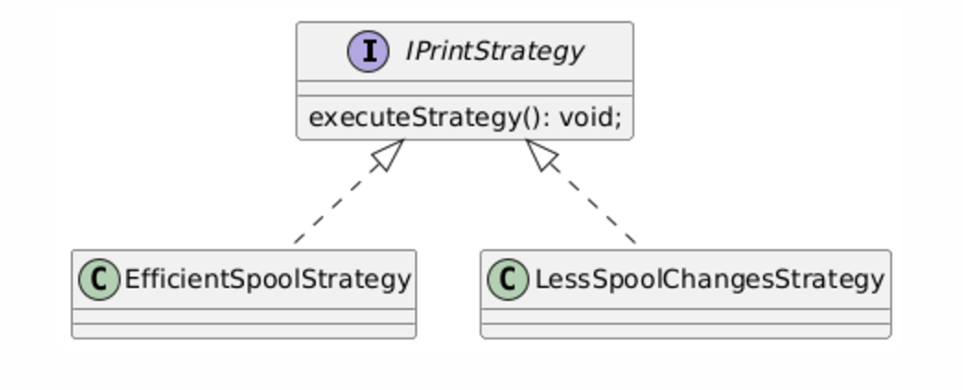

The approach to applying the Strategy pattern is similar. We create an Interface IPrintStrategy and two classes, which implement it accordingly.

In the PrinterManager class, we can now change the strategies on the runtime by having a setter for a IPrintStrategy instance.

## 2.3. Global Overview

**Figure 14**

*A Sketch of Our Design. Application Level Related Classes and Models are Split Accordingly*

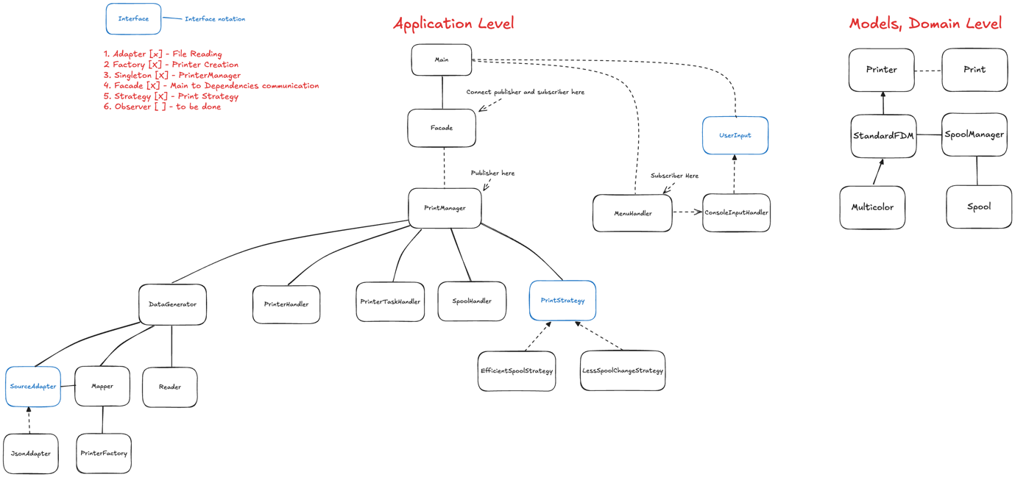

On the given diagram, we present a sketch of a system after applying the design patterns and SOLID Principles. A box with blue stroke represents an interface. We have used UML standards for drawing relationships. However, for the sake of making diagram not as cluttered, considering the amount of new introduced classes and interfaces, we have not modeled the relationship between Application classes and Model classes.

One thing that needs more clarification is the Model classes that we presented on the right of Figure 14. We decided to change the current inheritance chain of printers a little bit. As previously mentioned, HousedPrinter is redundant and will be replaced with isHoused Boolean value.

We have introduced a new class SpoolManager though, that will handle the spool management more efficiently. Current logic related to managing spools is odd and not flexible. What if we want to add another spool to multicolor?

**Figure 15**

*Odd-Ball Solution to Managing Spools Now*

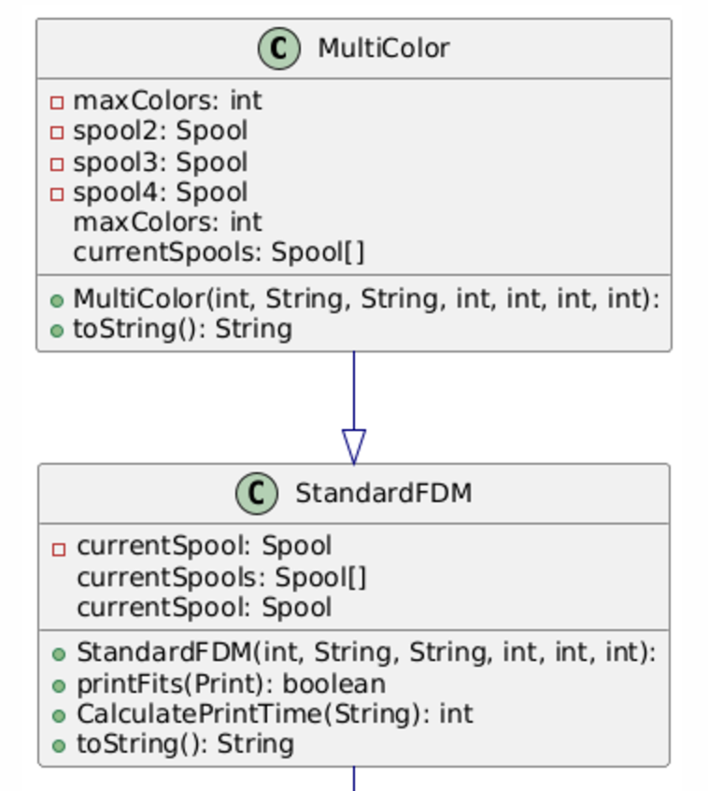

A SpoolManager will try to provide abstraction on managing spools in a more centralized way.

**Figure 16**

*SpoolManager*

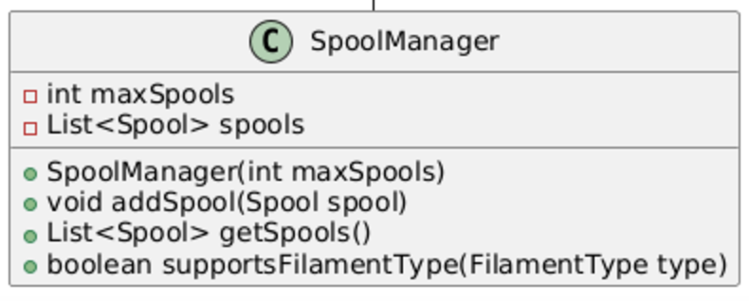

Also, as presented on the diagram, we have used an Interface for user input adhering to Open-Closed principle. For now, we will use only ConsoleInputHanlder class, but with this setup we are able to “inject” other type of inputs in the future.

# 3. Implementation

## 3.1. Implement Your Design

We have begun to implement our changes in original codebase, however, it contained so many errors during execution and generally was hard to refactor. That’s why we have created a new folder and started the implementation from scratch there.

We started off with building the structure of our design, including façade, specific handlers and domain classes. There we had to make choices which methods should remain in which appropriate classes. As we began to dig the codebase, some design fine-tunings had to be introduced.

The Main class in our implementation is now purely intended for user interaction. This means taking user input and displaying output. All the logic is abstracted from Main by using Façade design pattern. The output is dependent on DTOs, which we introduced to simplify data transfer between layers. DTOs help to decouple the domain logic from the user interface by providing only the necessary data for display. Using DTOs also required us to implement logic to convert between domain models to DTOs. Although it added some initial effort, it greatly improved the overall clarity and scalability of the code.

As far as mistakes of our design are concerned, we had to make changes to our printer’s structure. We have introduced `SpoolManager` interface and now StandardFDM and MultiColor implement it differently, overriding spool changing behavior. Another inconsistency on our initial design is the connections between classes. They were not really accurate in some cases.

To sum up, we think our design is solid. We didn’t have major changes and refinements, all the explained above was either improvements or, somewhat, cosmetic changes.

## 3.2. Extension of the System

Implement the new extensions. Write down the problems you encountered and how you solved them. For example: What and why did you have to change your designs?

### 3.2.1. Observer

According to expansion, the observer should notify dashboard with number of fulfilled prints and spool changes. Let’s focus on each of these separately.

To start off, we had to implement the base structure for this pattern, and again we referred to documentation on the [*refactoring.guru*](https://refactoring.guru/)*.* That required us to create `Dashboard` class and modify menu to contain new option. Furthermore, we had to decide which information should observer notify subscribers with. For that purpose, we have created `PrintEvent`, that just contained two integer required variables. Each subscriber is notified with `PrintEvent` when required.

To track number of fulfilled prints, we have made the following:

* PrintManager implements Observable interface. When user registers a completed print, the number of fulfilled prints is incremented, and subscribers are notified
* Dashboard implements Observer. When notified, local variable of fulfilled prints is updated.
* Now when user wants to check the dashboard, Dashboard returns a string with most recent data concerning fulfilled prints.

Dashboard is stored within the Façade. When user wants to display the statistics, appropriate façade method that returns a String is called. This method, in turn, executes the `getStats()` function inside Dashboard class.

When it comes to tracking spool changes, we had to do more tweaks. The logic of changing spools is abstracted by strategies implementation. Thus, tracking changed spools gets a bit more complicated. We come up with the following design solution:

**Figure 17**

*Updated Structure of Strategies*

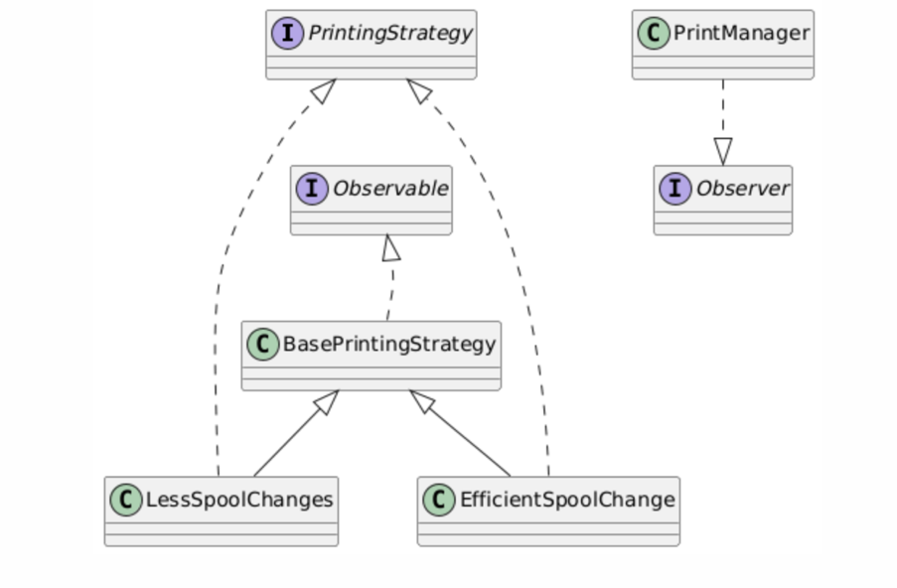

* PrintManager becomes an Observer. Why? To observe spool changes in strategies, without tight coupling.
* Whenever a spool is changed by either of Strategies, PrintManager is notified with number and updates the count.
* As we have explained above, PrintManager is also being observed by Dashboard. So, when a spool is changed, PrintManager is notified, which, in turn, notifies Dashboard with most accurate data.

### 3.2.2. Integration of a Multicolor Printer

For proper handling of a printer that is housed and capable of multicolor printing, a variable isHoused was added to the abstract printer class. This variable indicates whether the printer is a home printer or not. Based on the type field from the data source, the PrinterFactory creates the appropriate printer model using the static function fromMap. On Figure 18, the UML diagram of the PrinterFactory is shown.

**Figure 18**

*Printer Factory*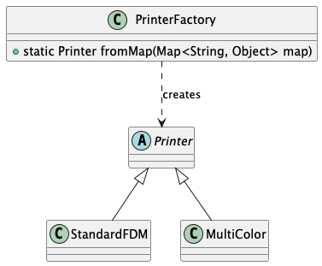

Since this logic was already incorporated during the system design, there were no issues with the implementation. The main problem came from the JSON data itself. If we use isHoused in the model, it should also be stored in the JSON in the same way. However, in this case, it was not.

### 3.2.3. Adding Support for CSV Source

As planned during the design stage, the task of the SourceAdapter is to convert any data source into a list of HashMap, where the key represents the attribute of the model, and the value corresponds to the attribute's value.

Each model in the system (or factory) must have a static function to read itself from a HashMap, called fromMap. By transforming any source into a list of HashMap, it becomes straightforward to generate models based on them.

At the early stages of development, only the JsonAdapter was implemented, and its implementation did not raise any issues.

However, the situation with the CsvAdapter is different because a CSV file may or may not contain headers. To address this, the following solution was implemented: if the data source is a CSV file, its headers are used as keys. If it is specified that headers are absent, the column index is used as the key instead.

The fromMap method for each model was adapted to this logic, which, on the one hand, made the method somewhat cumbersome, and on the other hand, further complexity is simply not feasible.

### 3.2.4. Implementing the Second Printing Strategy

To be honest, we didn’t implement the expansions in the given sequence. So instead of implementing observer pattern first, we have built parts of the strategy pattern extension.

First, we have setup necessary structure for strategy pattern according to [*refactoring.guru*](https://refactoring.guru/) website. After that, all it was about is connecting these classes to existing setup (Main, PrintManager and PrintTaskHandler). We made sure it’s possible to change the algorithm on the runtime through the menu and begun the actual implementation.

We had to re-implement the `selectPrintTask()` for the first strategy (LessSpoolChanges) and test the output. After making sure the correct printers were selected for different tasks, we have started developing second strategy. At that time we have noticed there are a lot of common functionality between two strategies and we made a decision to introduce new class that would act as common ground with shared functionality. Please refer to figure 19.

**Figure 19**

*Structural Strategies Setup*

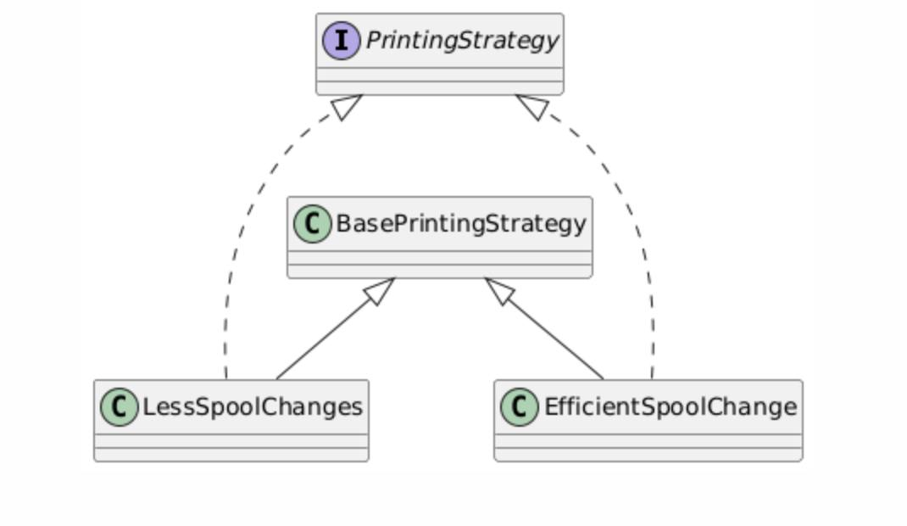

Overall, with our design we didn’t encounter any problems or difficulties with implementation.

## 3.3. Testing

Include proof that your code is correct, you can do this with software testing. Add the results to this chapter.

For automated testing of the application, unit tests were written and placed in the module cleancode/src/tests.

The main idea of these tests is simple: in app, the list of available printers always includes only one printer—the one being tested to determine whether it can successfully print a specific Print or not.

The output of these tests is generated as CSV files, which are saved in the tests folder.

After comparing our results with the Truth Table provided in the assignment, we identified one factual error and one oversight in the Truth Table.

3.3.1. Factual Error in the Truth Table

According to the Background Information section of Assignment 3D PrinterScheduler, ABS requires a printer that is housed to prevent warping. However, in the provided printers.json, Serenity has "type": 1, which means it is not housed and, therefore, cannot print ABS. However, the Truth Table shows that it can.

3.3.2. Oversight in the Truth Table

Although the Red Dwarf printer is technically capable of printing the Moon Lamp, the provided spools.csv and spools.json do not include the required minimum necessary filament. Therefore, if the data provided in the assignment is not modified, the Moon Lamp cannot be printed at all. Please refer to figure 20**Figure 20**

*Correct Truth Matrix*

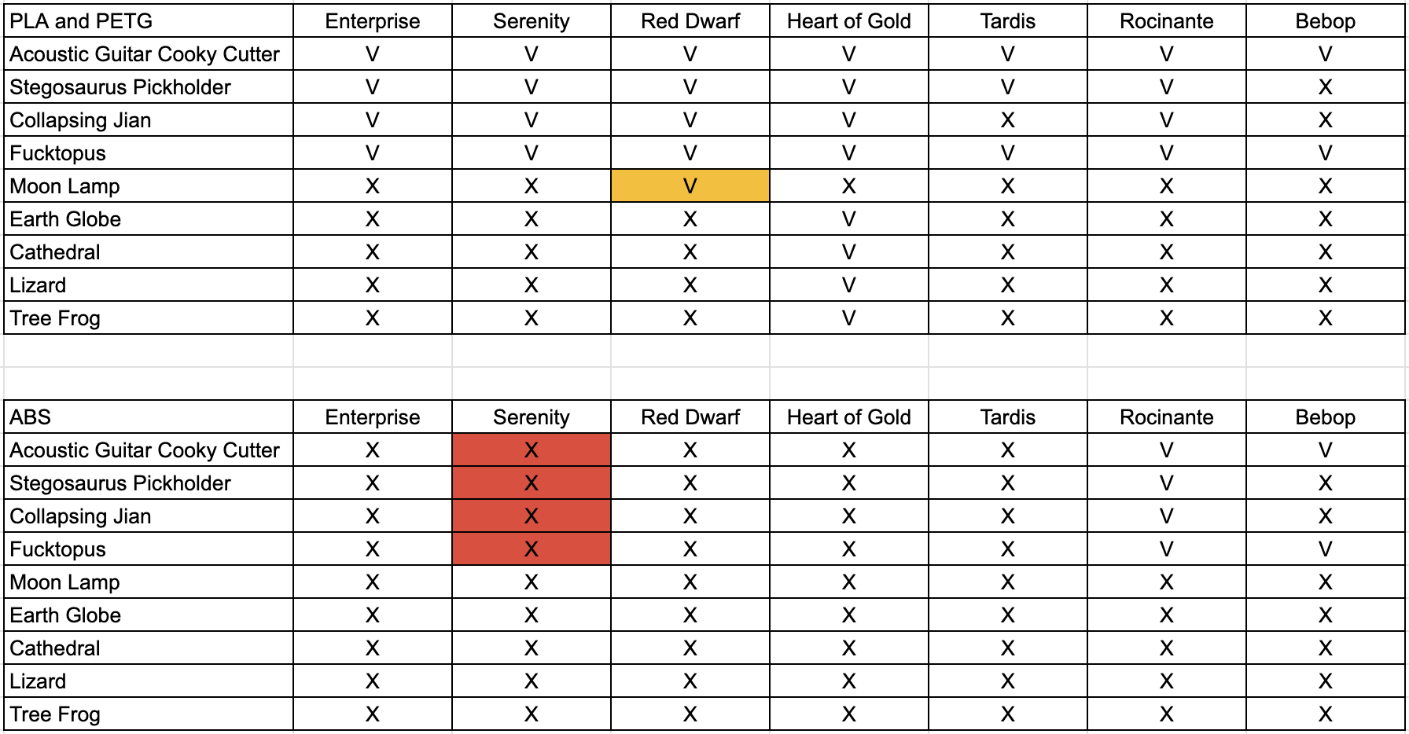

Table 1 shows the cases that were manually tested.

**Table 2**

*Test Cases*

|  |  |
| --- | --- |
| **Use case** | **Proof of work** |
| When adding a print it should be assigned to a printer that can physically print it and a spool change is initiated. |  |
| When adding a print and there is no printer available that can physically print it is added to the queue. |  |
| When a printer is marked as ready a print is selected that fits and uses the same spool. |  |
| Starting the queue will attempt to fill all printers. | An attempt to fill all printers was done having 9 pending tasks. |
| When adding multiple prints in the order of Blue, Red, Blue and a correct printer has a Blue spool. It will select the third print when it is marked ready. |  |
|  |
|  |

Thus, the conducted tests confirmed the application's correctness and revealed errors in the source data.

# 4. Conclusion

**Figure 21**

*Final Design*

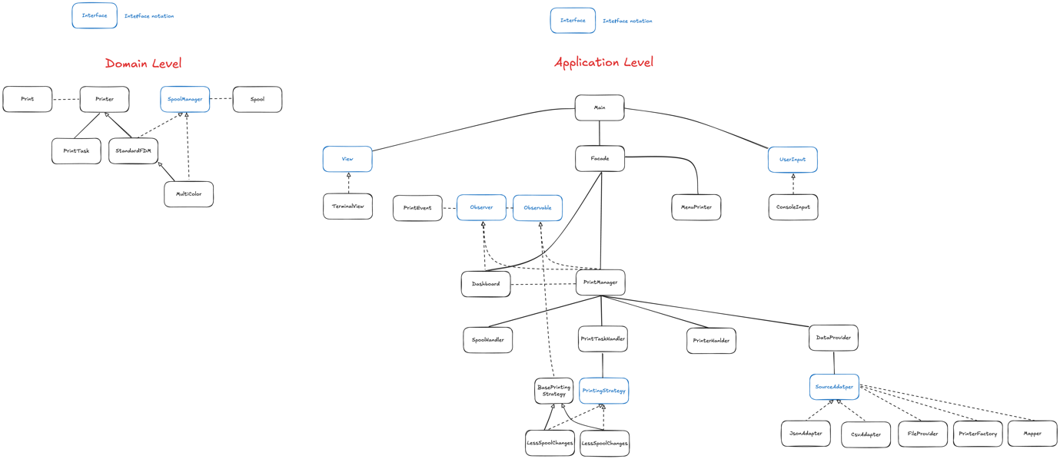

**Figure 22**

*Application*

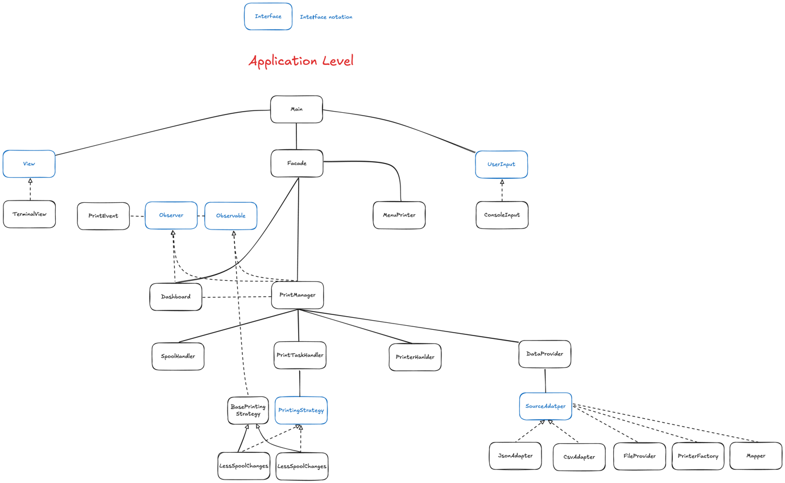

**Figure 23**

*Domain*

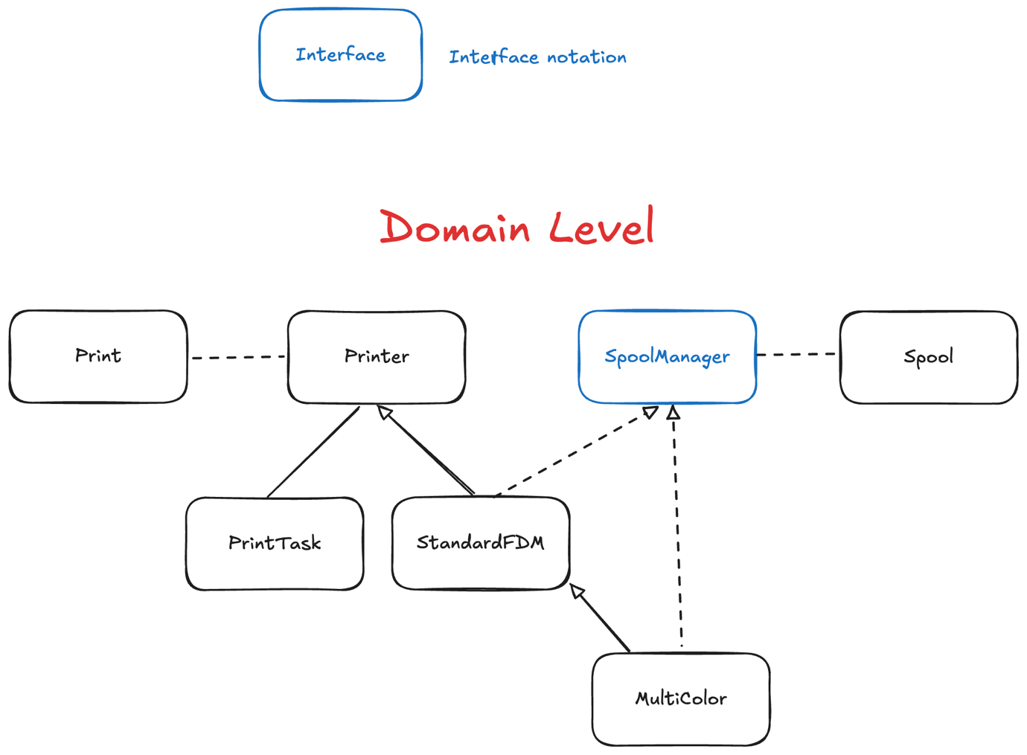

Drawing up the conclusion, we have tackled the most problems of the initial codebase. By applying SOLID principles, we got rid of tight coupling and classes being too dependent on each other. Design patterns introduced more flexibility and allowed system to be extended with relative ease.

Most importantly, our new design made codebase more modular and less coupled. If Jack ever wants a Swing, JavaFX or SaxionApp application, the main business logic can easily remain unchanged. In our design there is a clear separation between “UI” and “Domain” level due to efficient Façade usage. Façade returns DTO’s and Strings most of the time which can be handled and displayed differently.

Application is now more flexible. If Jack ever wants to read data from any file format apart from JSON or CSV it is possible, a new adapter class should be added. If Jack wants to introduce more task selection strategies, it can be also done without any hassle.

To conclude, we have targeted the problems of initial codebase and came up with a scalable and testable refactored version.

Part 2: Software architecture

# 5. Software Architecture

* Discuss alternatives you decided against and why!
* Conclusion – Convince the reader about your design!.

## Introduction

As the business expanded, Jack needs a new, bigger system. As stated, it is important that the printing is mostly automated. Employees would need only to remove the print and change spools.

In this chapter, we present our vision of system architecture, that can meet Jack’s new requirements.

## Use case diagram

**Figure 24**

*Use Case*

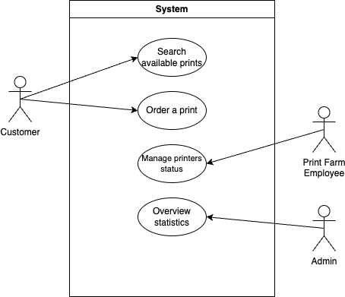

The use case above (Figure 24) represents the interaction between actors and the system.

Customer actor represents a user of the web shop. Most importantly, customer wants to use the system for print ordering. Another use case for the customer is searching for available prints. The customer might be interested in investigating which prints are technically available to be printed and what is the printer support. A customer might be interested in receiving that information, but that doesn’t necessarily mean that the customer wants to order a print. We have decided to depict that action, being “inspired” by library use case diagram example, where the customer had a separate action of “searching books”.

The next actor, Employee, interacts with the system in order to manage printers’ status. As stated in the assignment description, the employee gets a signal that printer is done, and their sole purpose (in terms of system usage) is to register the print completion.

Finally, admin or owner main goal is to oversight the statistics of print farms.

## System Sketch

**Figure 25**

*System Sketch*

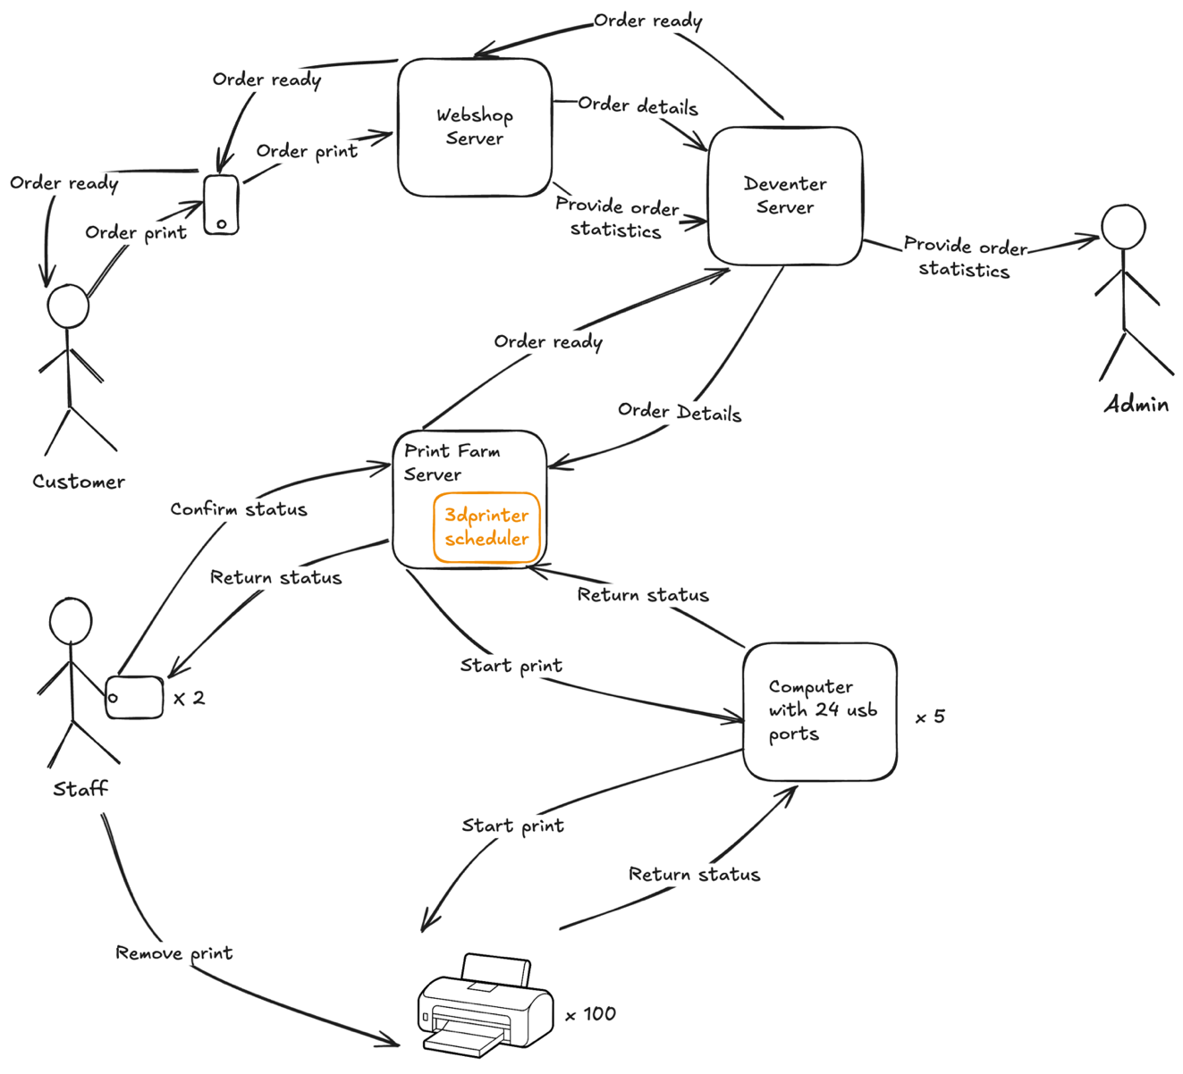

We have come up with the following sketch of the system. Figure 25 illustrates the abstracted flow of the main system functionality. From getting an order to fulfilling it.

As we brainstormed the possible solutions, several architectural decisions were made:

* Deventer represents an administrative office, managing print farm locations. It acts as a broker, assigning orders to correct locations. The advantage of this is scaling. If the demand increases, another print farm location is registered. It is also hidden from public internet for security reasons.
* Each print farm server uses the old 3dprinterscheduler software to get the printer suitable for the task. Then server can interact with the computers, that, in turn, have direct access to printer hardware and start actual printing jobs.
* Employee’s tablet communicates with server of the location. That server sends updates to employee and receives “completion” request back.

## Component + Deployment diagram

**Figure 26**

*Component + Deployment*

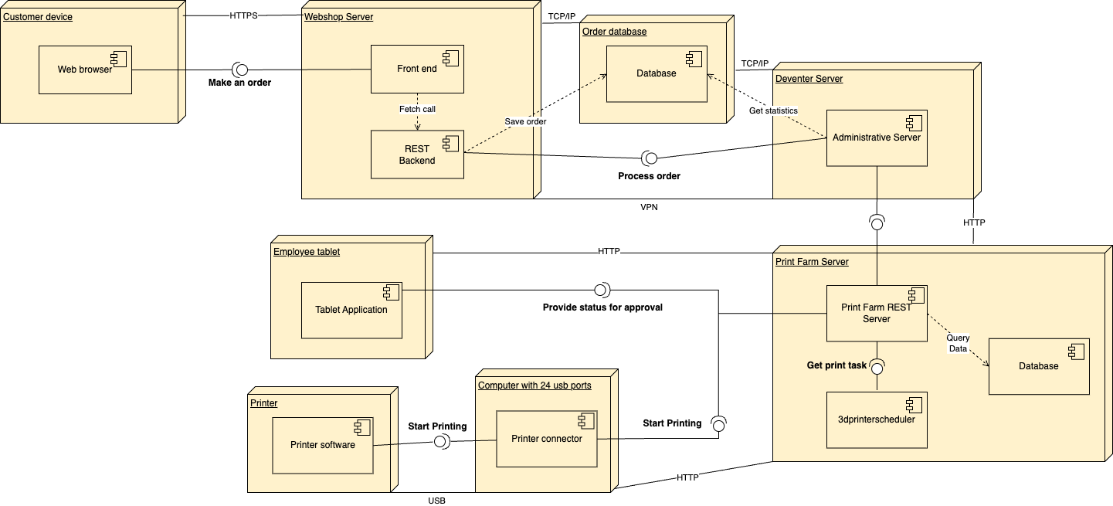

Figure 26 represents hardware nodes and software components they contain.

As was stated in system sketch description, the Deventer server is hidden from public internet. The web shop server is connected to it via VPN.

We have decided to make a database a separate hardware node. Both web server and Deventer server communicate with database either for saving and updating orders or retrieving statistics. If we were to put the database itself into one of the following nodes (web shop or Deventer server) then we would face direct dependency of these nodes. If the web shop is down, that means that Deventer Server cannot get statistics and vice versa. If the Deventer server is down, web shop cannot save orders.

Each print farm server, in fact, needs another database to store relevant information about spools and available printers. The print farm has a centralized server, that runs scheduler to get the printer, task should be assigned to. This server, then, communicates with one of the 5 computers on the farm, that have direct access to printer’s hardware, as they are connected to printers via USB. This computer then starts printing job and returns the status back to the server.

Employee, as stated before, communicates only with the main farm’s REST server. From there they get updates and register completions.

## Activity Diagram

**Figure 27**

*Activity diagram*

The activity diagram (Figure 27) illustrates the end-to-end process of placing and fulfilling a 3D printing order, starting from the customer’s initial request and ending with the final delivery of the printed item. The diagram begins at the Initial Node, where a Customer places an order (“Place an Order”). Next, the Webserver saves the order (“Save Order”) and notifies the Deventer Server, which then forwards the order details to the Print Farm server.

Once the order has been handed off, the Print Farm server enters a repetitive cycle (shown by “repeat … while (Print successful?)”) to manage ongoing print jobs. Within each iteration, the system updates the current print status, runs the scheduling algorithm, and selects a suitable printer. The Print Farm server then requests printer activation via the Computers with USB ports, which in turn assign the print task to an available Printer. The printer begins the actual printing (“Start printing”) and, upon progress or completion, sends updates back through the same chain, ultimately reaching the Print Farm server again.

After printing, the Employee is notified to approve the print status and remove the completed item from the printer. This cycle continues for as many items or iterations as needed. If the print is successful, the item is labeled (“Label print”), and the Print Farm server sends a notification to the Deventer Server, which updates the order status in its records. Finally, the Customer is alerted about the completed order and can pick up the delivery.

## Sequence diagrams

**Figure 28**

*Sequence Diagram – Placing an order*



On Figure 28 you can see that customer initiates checkout on the Webserver, selects a pickup location, and completes payment through the PaymentProvider. Upon success, the Webserver forwards the order details to the Deventer Server, which assigns the order to a pickup point (Amsterdam). The Deventer Server then confirms completion back to the Webserver, allowing the Webserver to notify the customer that the order is ready for pickup.

**Figure 29**

*Sequence Diagram – Processing order*



This Sequence Diagram (Figure 29) focused on processing the order after it has been received on the Deventer Server and begins with the Deventer Server sending a newly received order to the Print Farm, which confirms it is ready to handle it. The Print Farm then asks the USB-connected computers for current printer and filament spool information, updates its internal records accordingly, and requests a suitable printer from the 3D Scheduler. Once the scheduler responds with the best choice, the Print Farm delegates the printing task to that printer through the computers. The printer confirms that it has started printing and periodically provides status updates, passed along by the computers to the Print Farm.

When printing finishes, the Print Farm notifies an employee, who physically removes the completed item from the printer, labels it, and confirms the successful outcome. This information is then relayed back to the Print Farm, which updates its records one final time and reports completion to the Deventer Server. In response, the Deventer Server marks the order as complete, concluding the process.

## Architectural Patterns

**Figure 30**

*Design with scalability in mind*

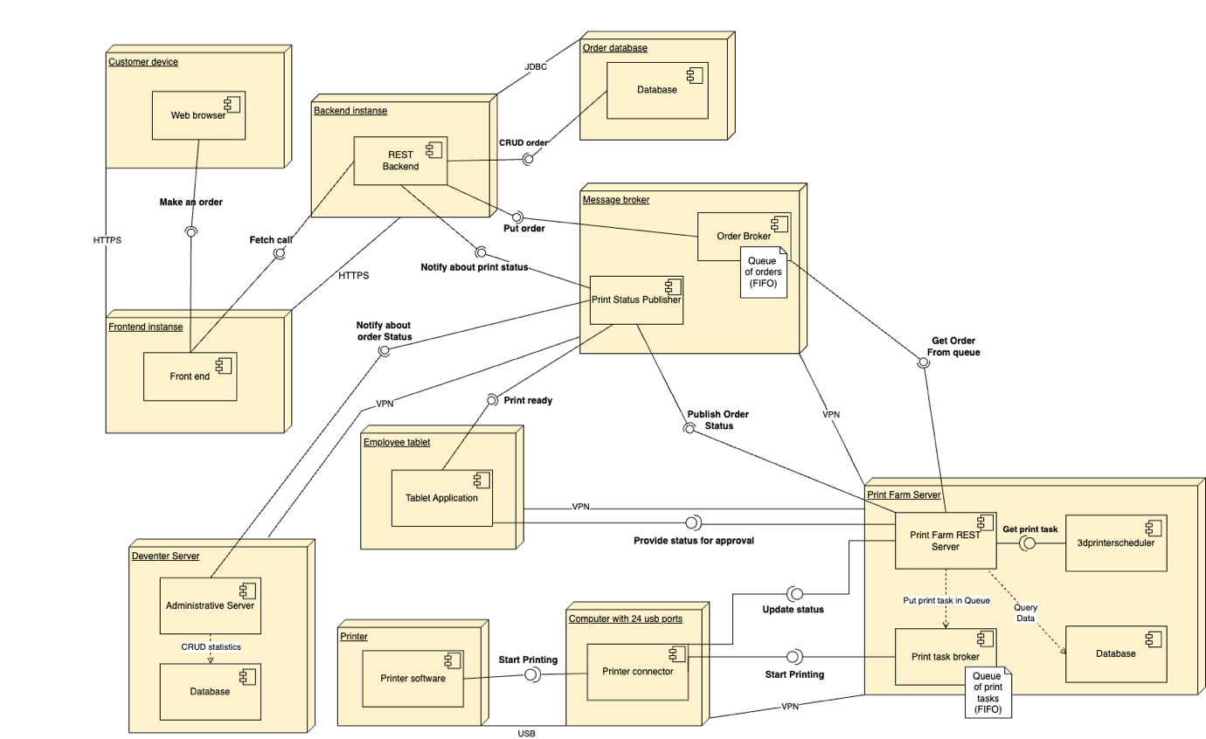

This diagram illustrates a combined Component and Deployment architecture for an order management and printing system. The main goal is to ensure scalability, reliability, and loose coupling between different parts of the system by employing two key architectural patterns: Publish/Subscribe and Message Queues.

Whenever a print job’s status changes (e.g., printing started, printing finished, or encountered an error), the Print Status Publisher sends out an event. Any service that cares about this event (like the Print Farm Server or Deventer Server) can subscribe to the topic and immediately receive a notification. This mechanism ensures real-time updates.

The Queue of Orders (FIFO) in the Message Broker and the Queue of Print Tasks within the Print Farm Server illustrate the Message Queue pattern. When the Backend places a new order, that order can be pushed into a queue. The Print Farm Server then dequeues orders as it becomes ready to process them.

A second queue is placed in the Print Farm Server, where printing tasks are queued. The computer with 24 USB Ports consumes these tasks in a FIFO manner and performs the actual printing. After printing, it sends an update back via the Publish/Subscribe mechanism for status updates.

This Message Queue approach allows for asynchronous processing and horizontal scaling, as you can add more nodes if number of customers grows – tasks simply get distributed among the available consumers in the queue.

The advantages of using these patterns would be, first of all, real-time notifications. Pub/Sub ensures that all interested services (Frontend, Employee Tablet, Deventer Server) receive updates about orders or print statuses directly. Message Queues, in turn, allow the system to handle order acceptance and print tasks without stopping the main application. Orders are enqueued, and the print operations can be handled in parallel. Combining Pub/Sub events with queued tasks means the system can handle an increasing number of orders, additional printers, or new services. Each component can scale independently.

By using Publish/Subscribe for notifications and Message Queues for asynchronous order and print task handling, this architecture remains scalable and extensible. Each module (from the Frontend to the Print Farm) can scale without affecting others.